**ESTIMATION OF BUSINESS EXPENSES**

**INTRODUCTION**

This involves estimating all the expenses required to start and operate the business, such as equipment, rent, inventory, and marketing. By calculating these costs upfront, business owners can better plan their budget and avoid unexpected expenses. This report delves into the fascinating realm of business expenses and provides a visual exploration of the various expenditures incurred by different business. It showcases the distribution of expenses, identifies key cost drivers, and highlights areas of potential optimization or concern. The visual representations allow for intuitive analysis, facilitating a deeper understanding of expenditure patterns and their implications for business performance. Decision-makers, financial analysts, and stakeholders can gain valuable insights into the financial health of businesses, identify areas of opportunity, and make informed decisions to optimize resource.

**Data Visualizations**

* Annual pay roll
* Advertisement cost
* Employee(insurance VS pension)
* Equipment costs
* Fuel
* Maintenance of buildings
* Power expenditure
* Rental payment machinery
* Taxes & licenses
* Transportation

**Dashboard**

* Expenses insights
* Business Expenditure Overview
* Expense Breakdown Insights into Diverse business Cost

**Story**

* Expenses 1
* Expenses 2

**Purpose**

* Cost estimation is to give project stakeholders accurate information concerning the related project costs. It is easier to make lasting decisions if there is information to back them up. Cost estimation also gives clients value-aided options and helps clients minimize expenses.
* Understanding expenses can help you examine a brand's business model and interpret how it generates profit.
* Fresh Books has a develop business quality that help you build an estimate quickly and easily.
* Create an estimate when you want to give your customer a quote, bid, or proposal for work you plan to do. The form looks similar to an invoice, but instead of charging your customer, you're giving them info about your proposal and what they can expect to pay.
* The purpose of estimating is to forecast (predict) the cost required to complete a construction project in accordance with the contract plans and specification.

1. Problem Definition &Design thinking

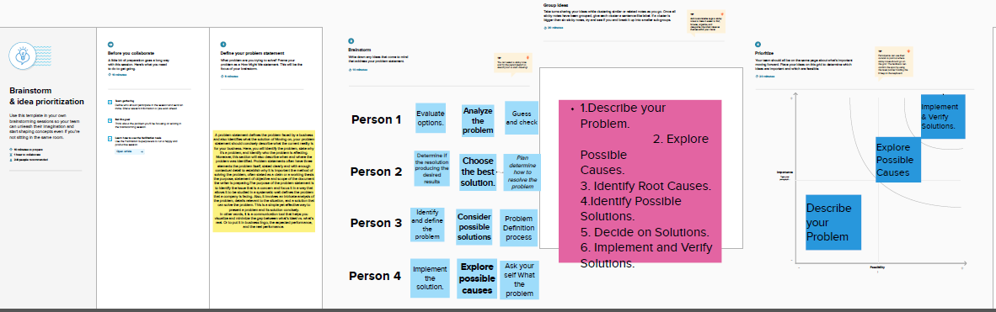

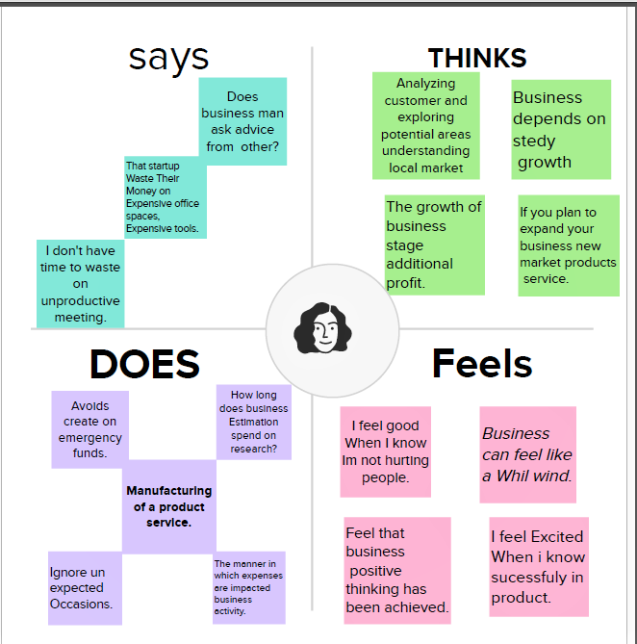

**Result**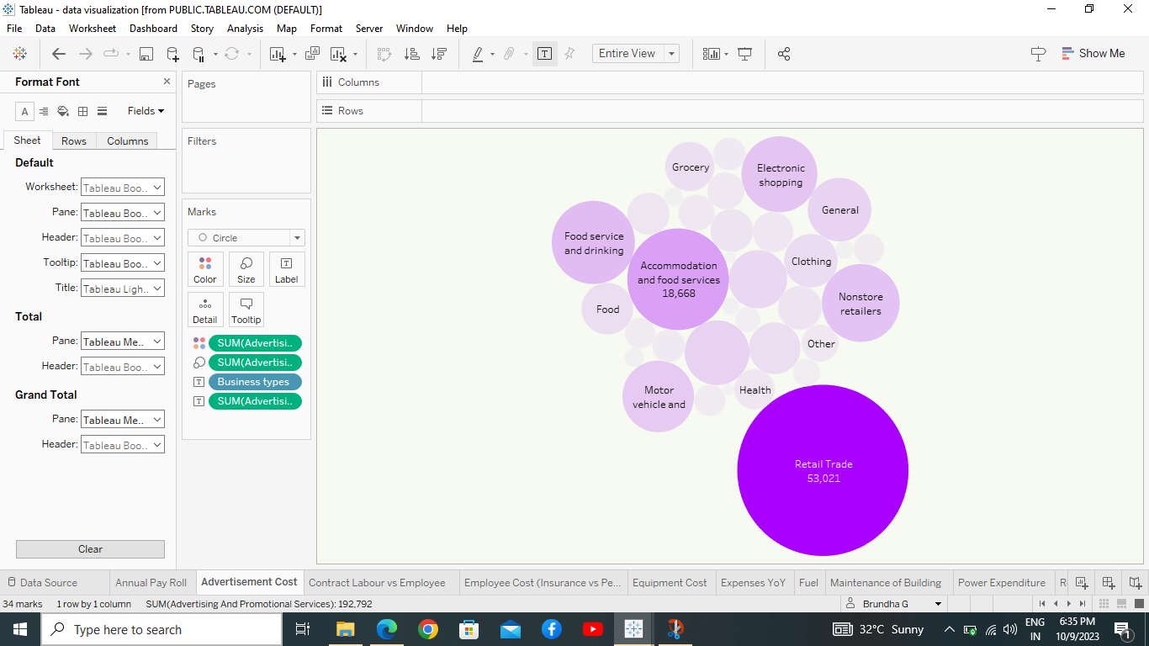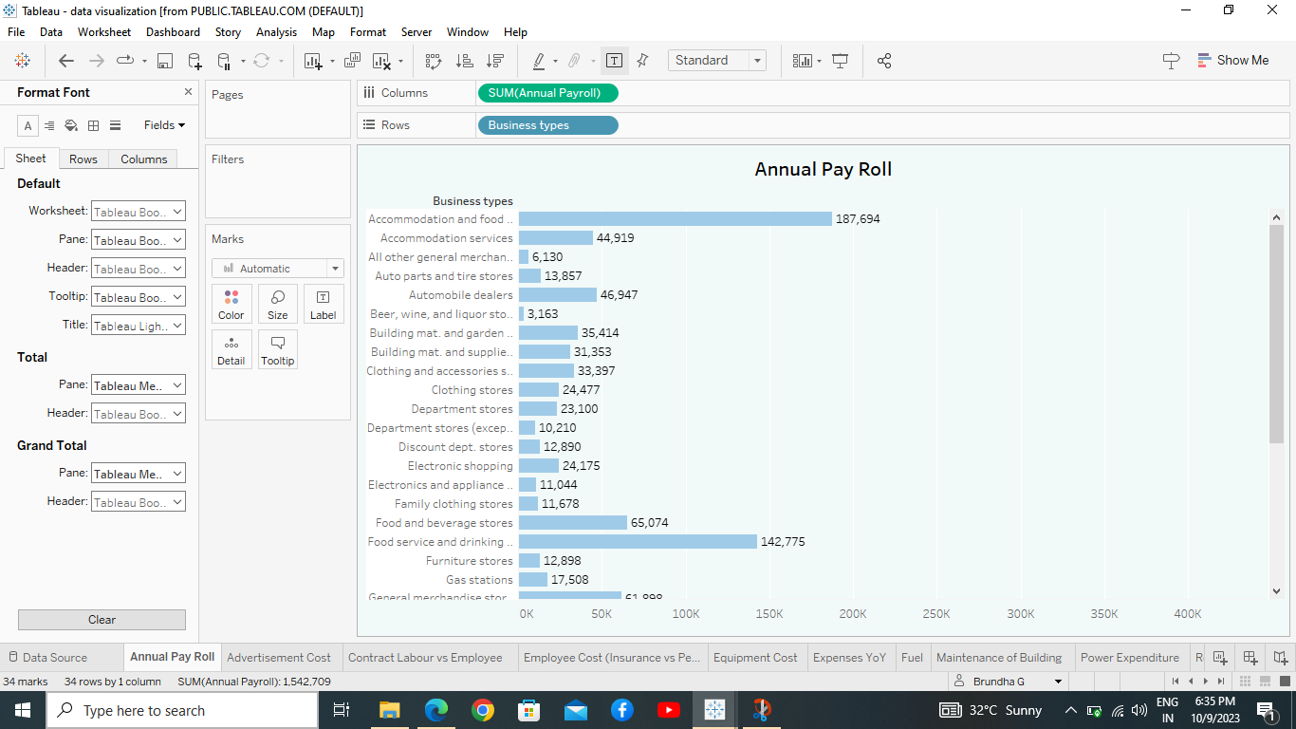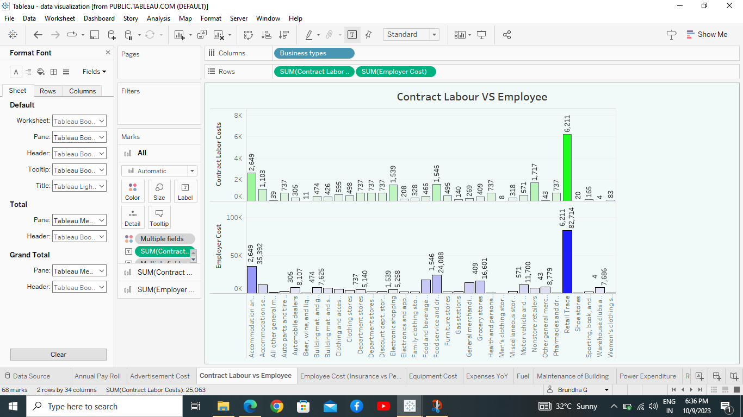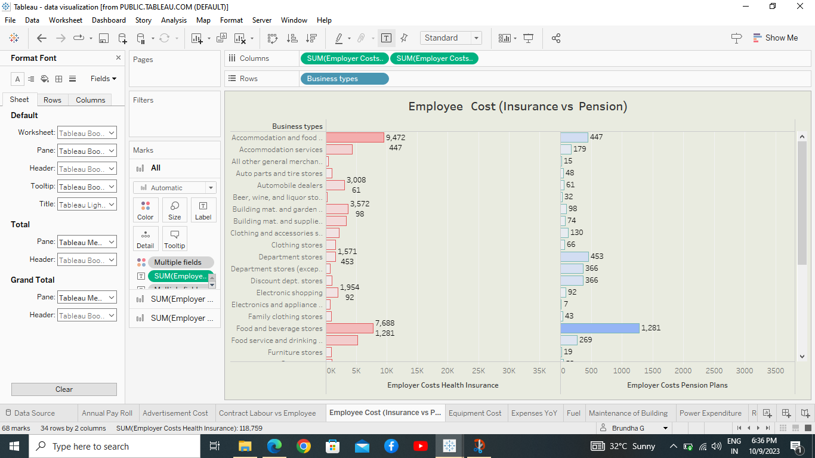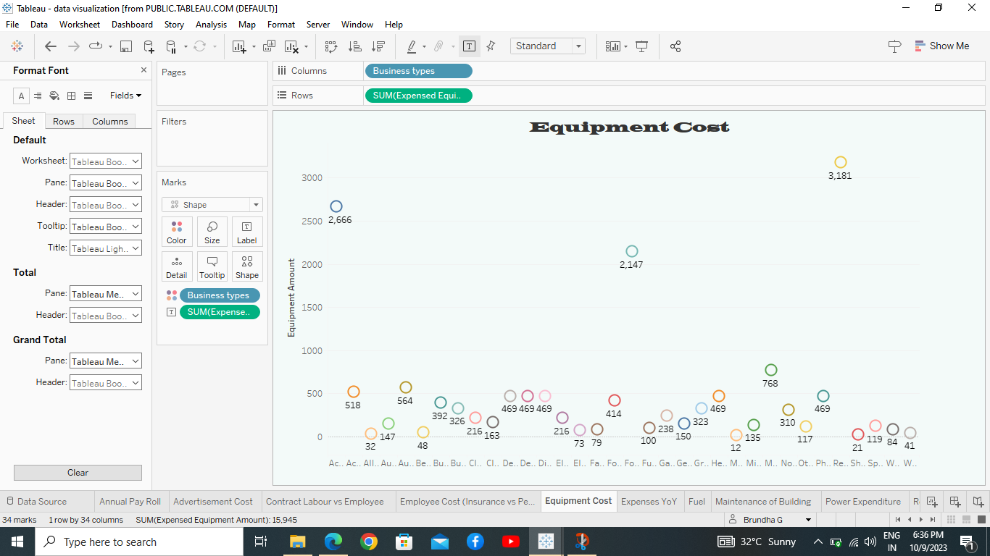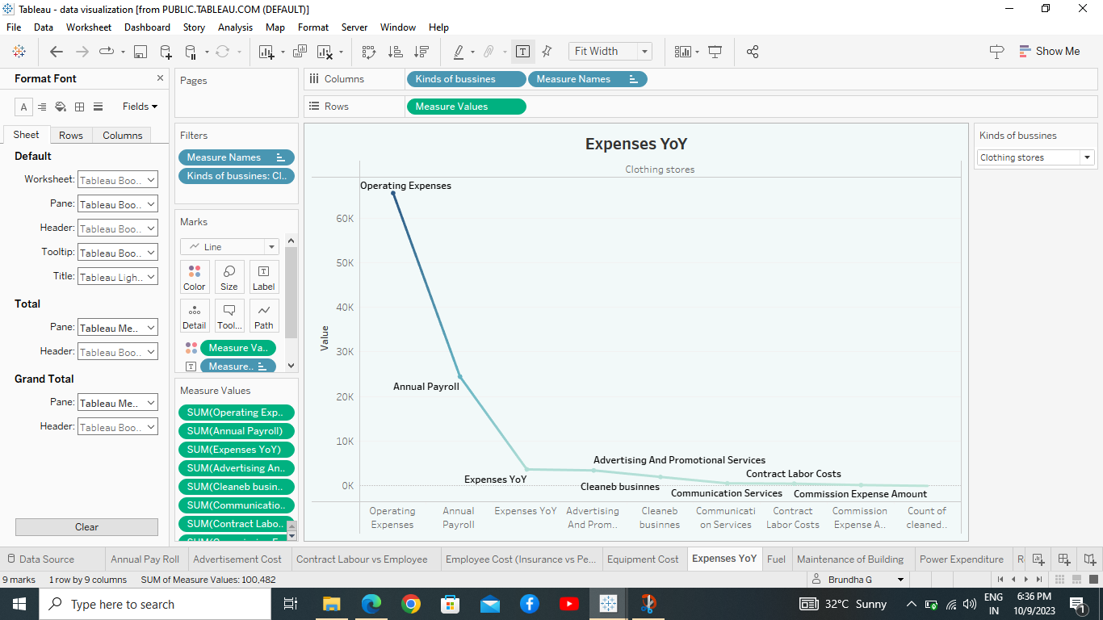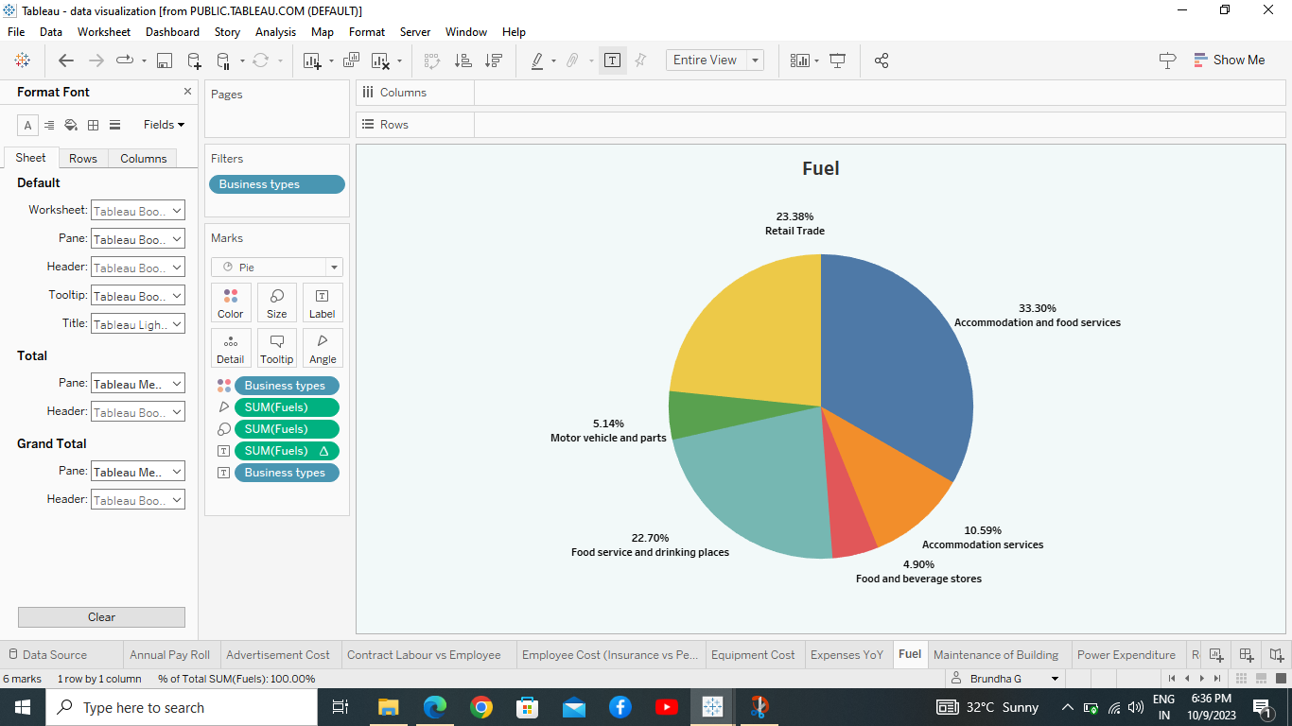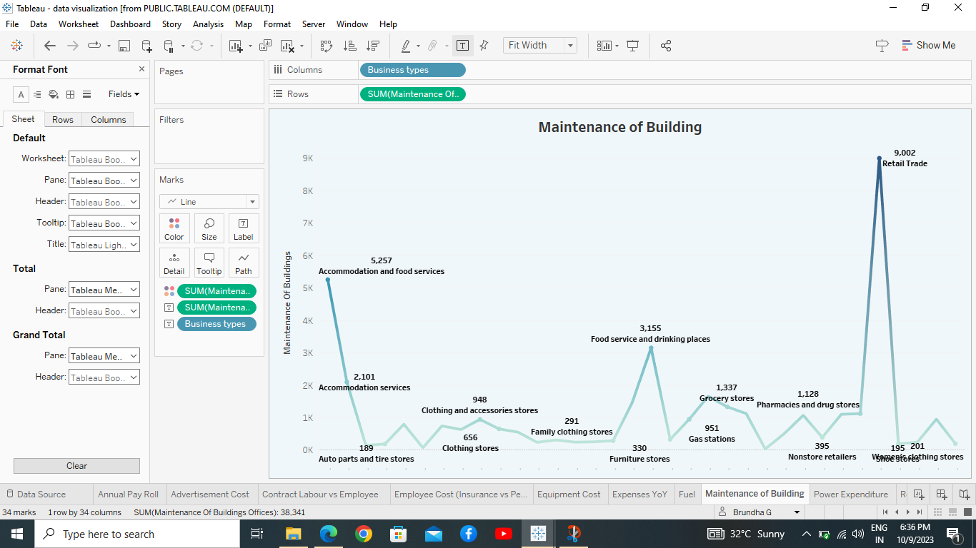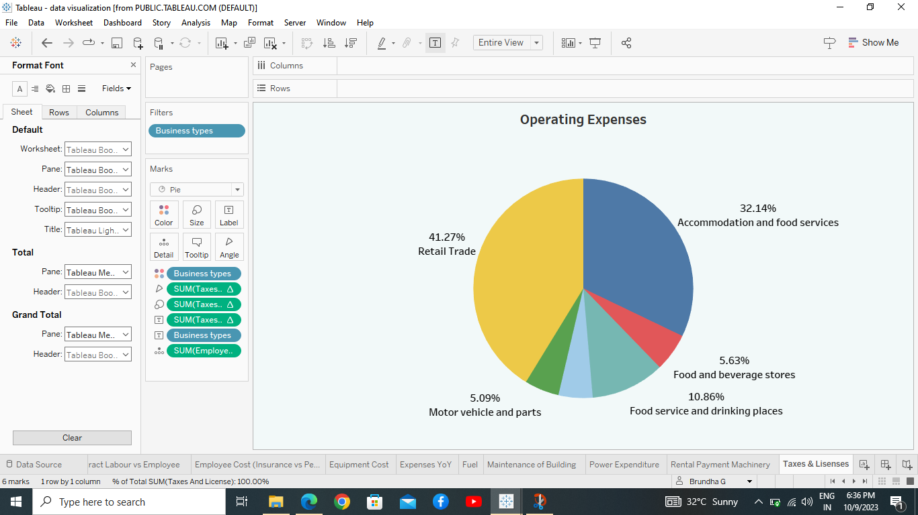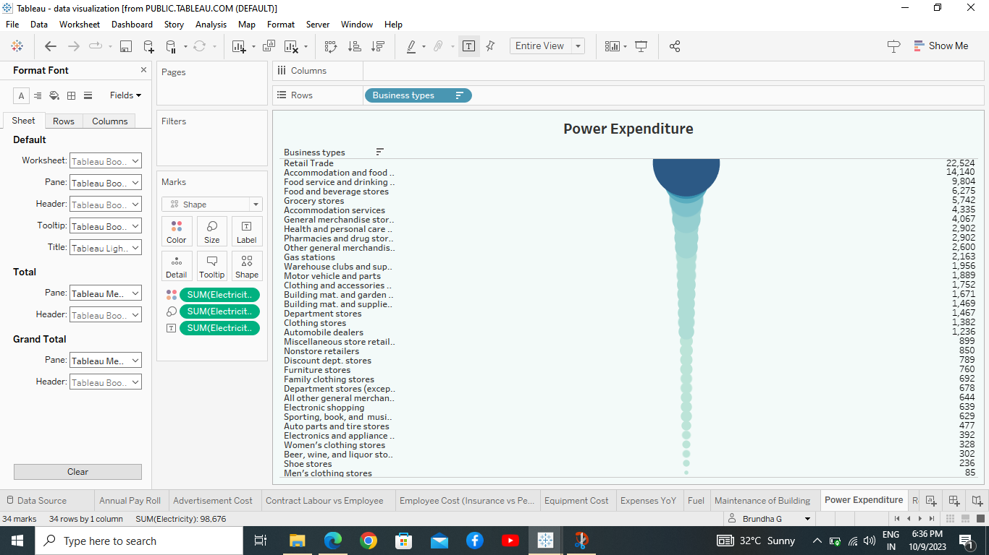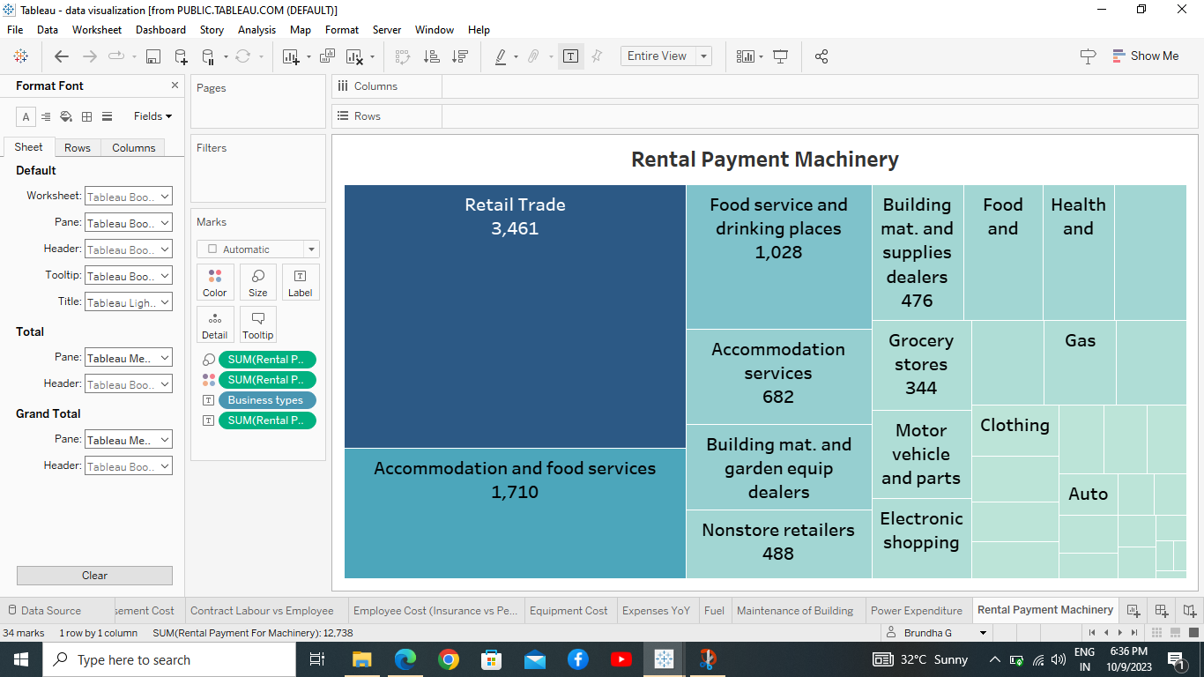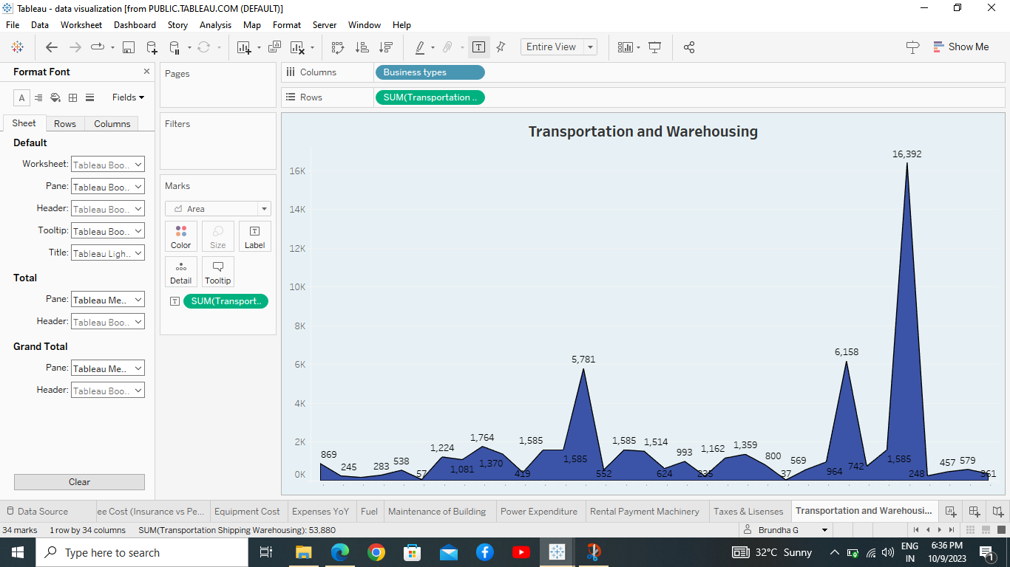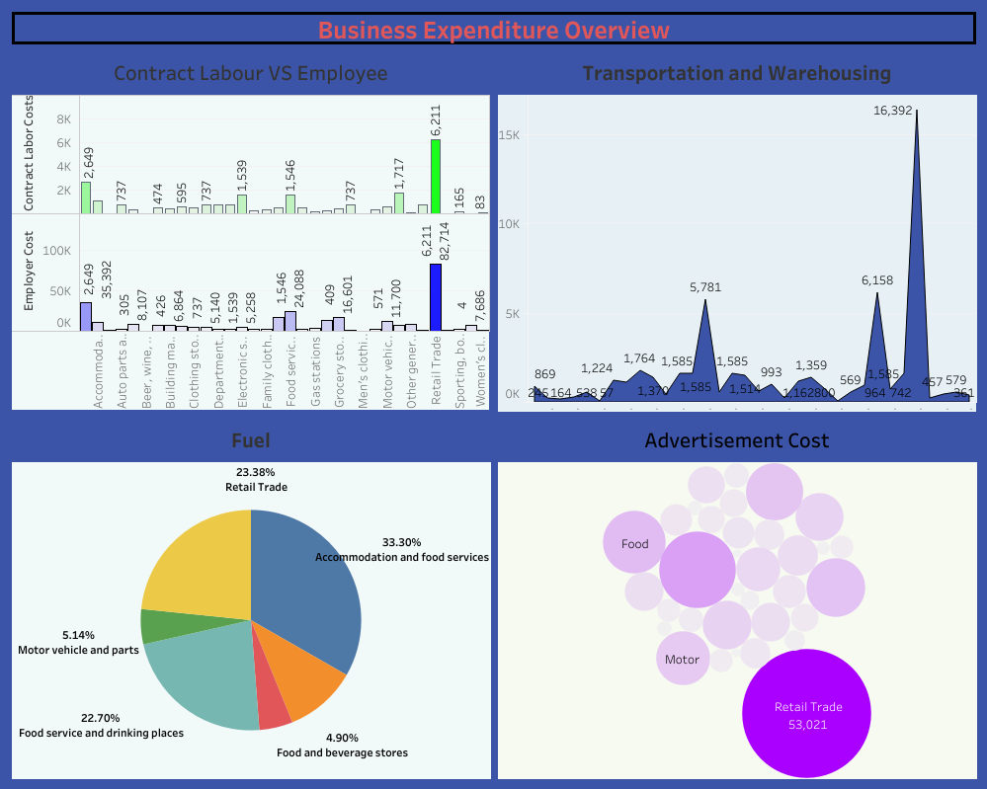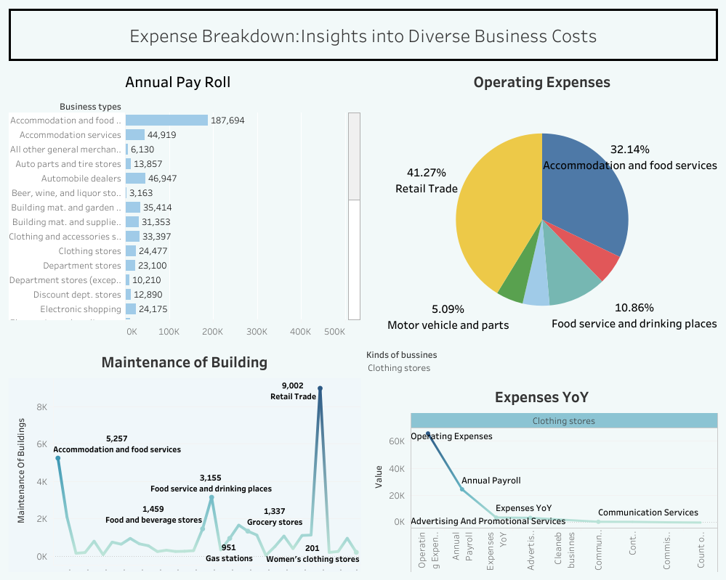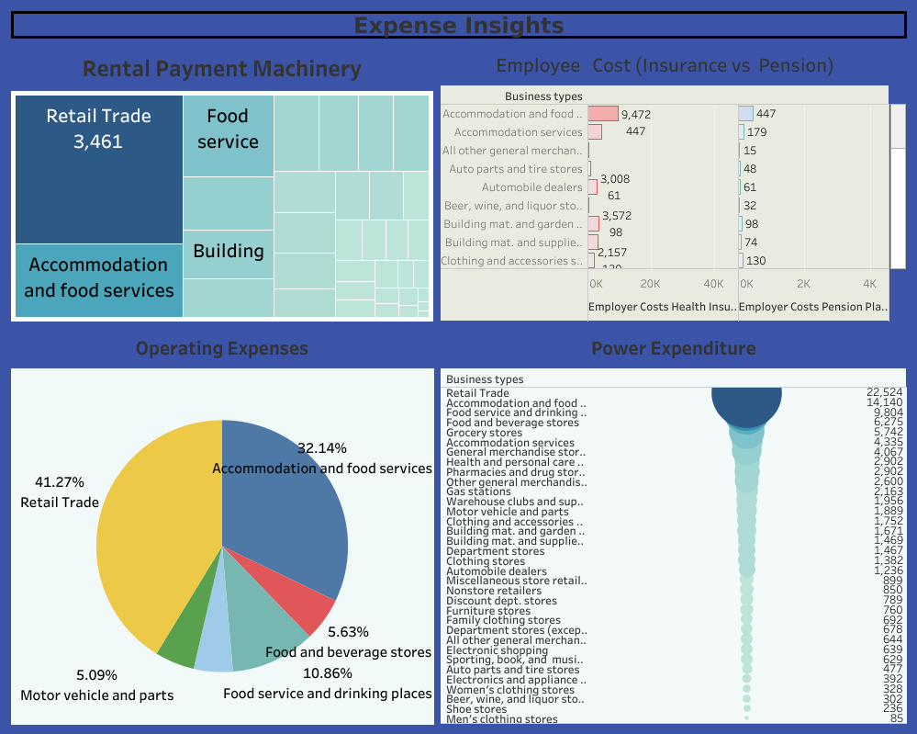

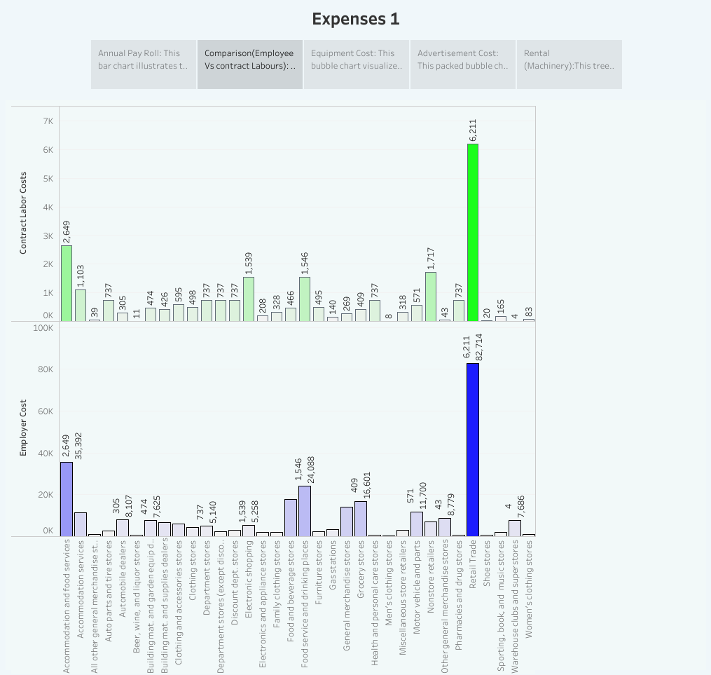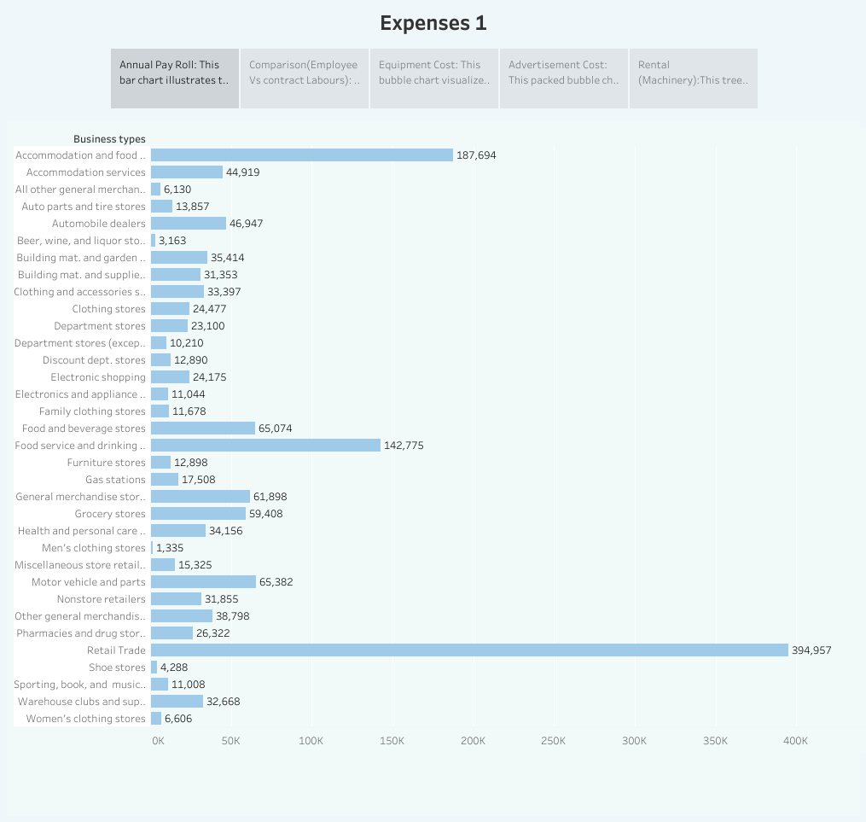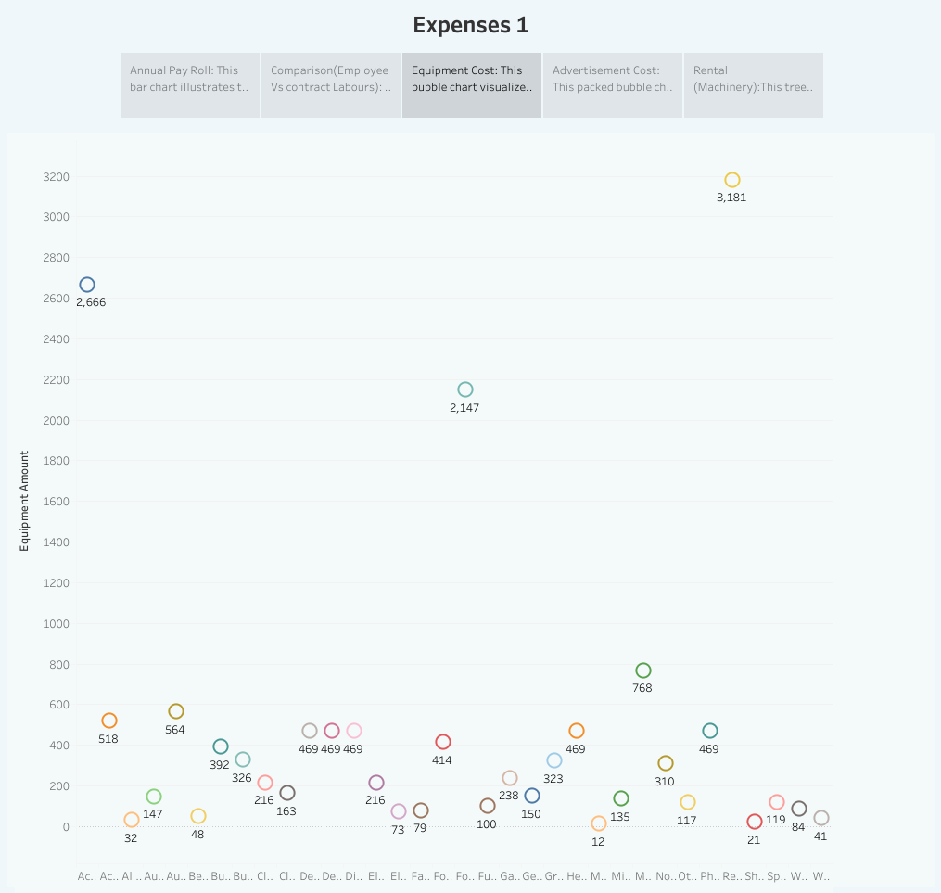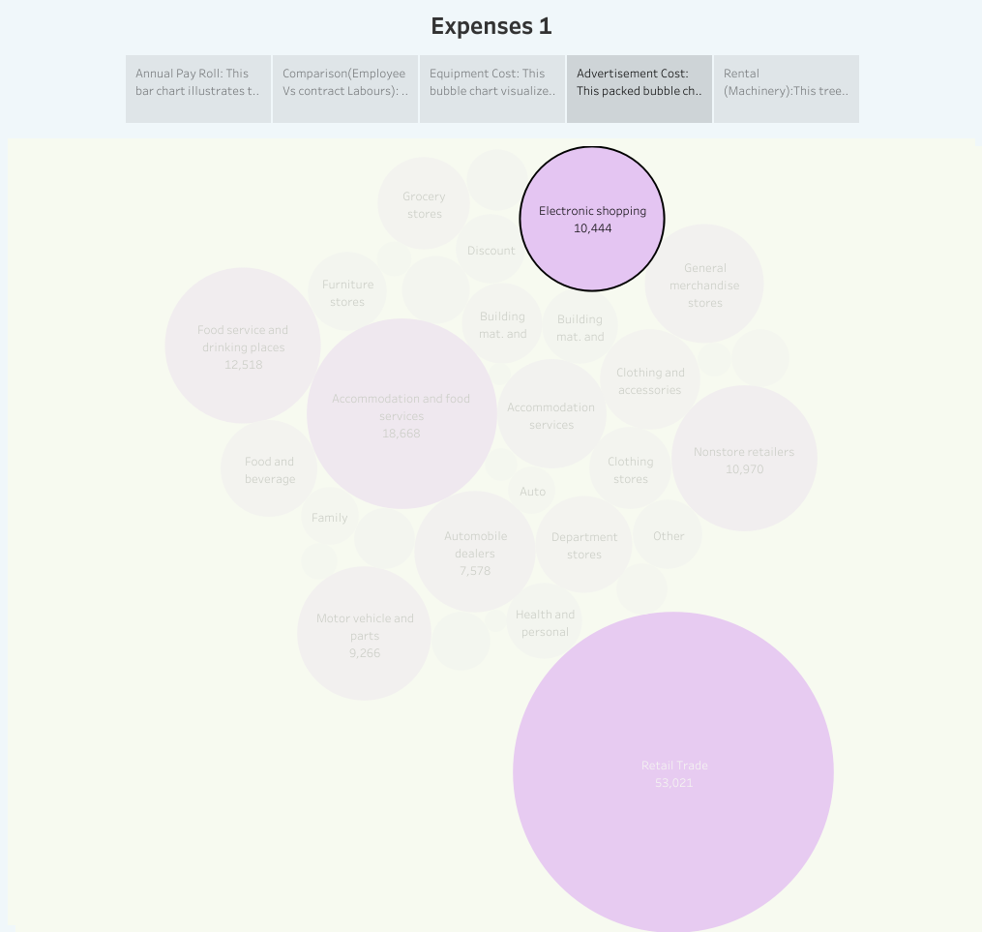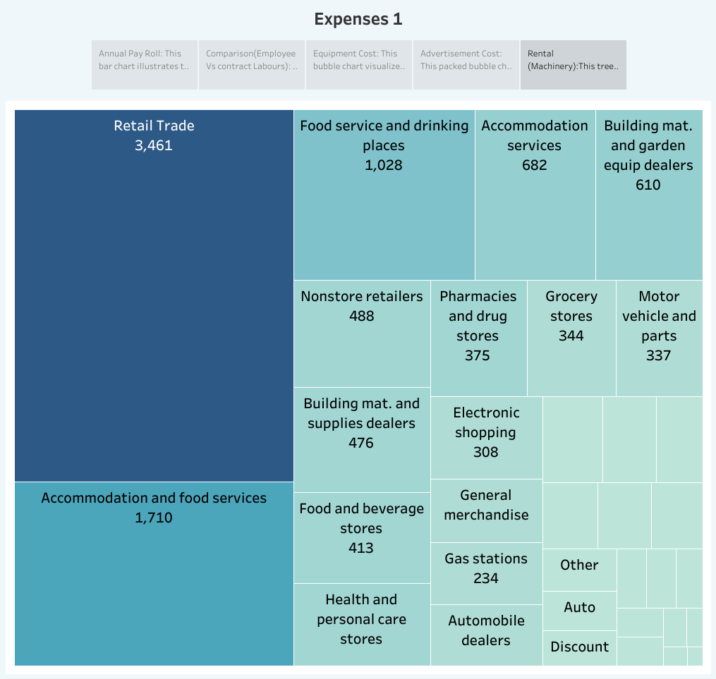

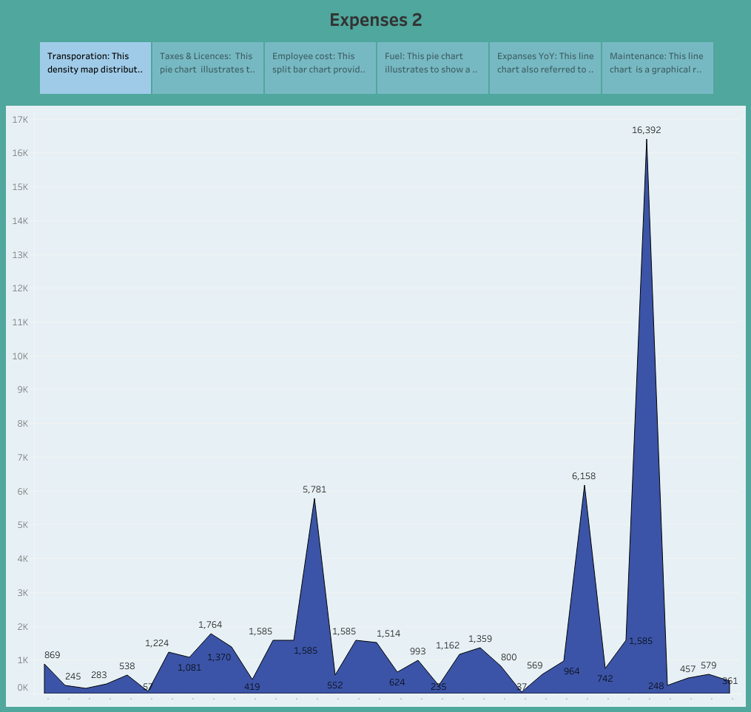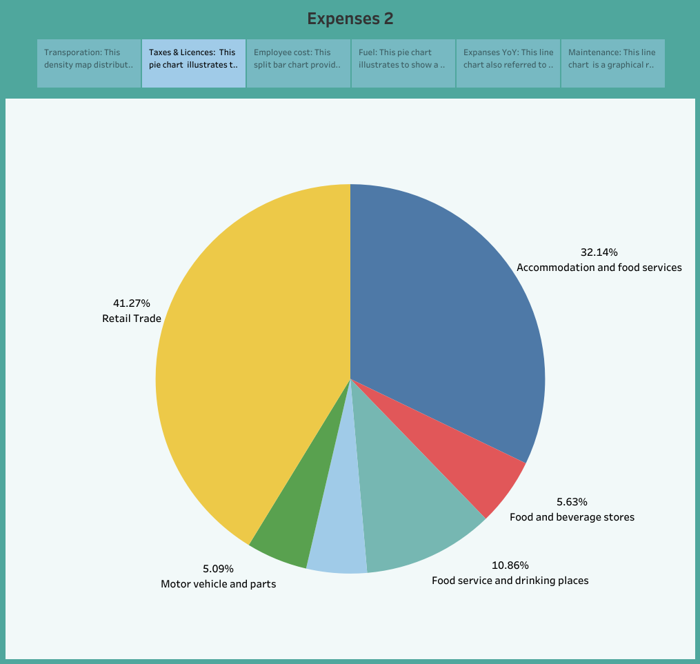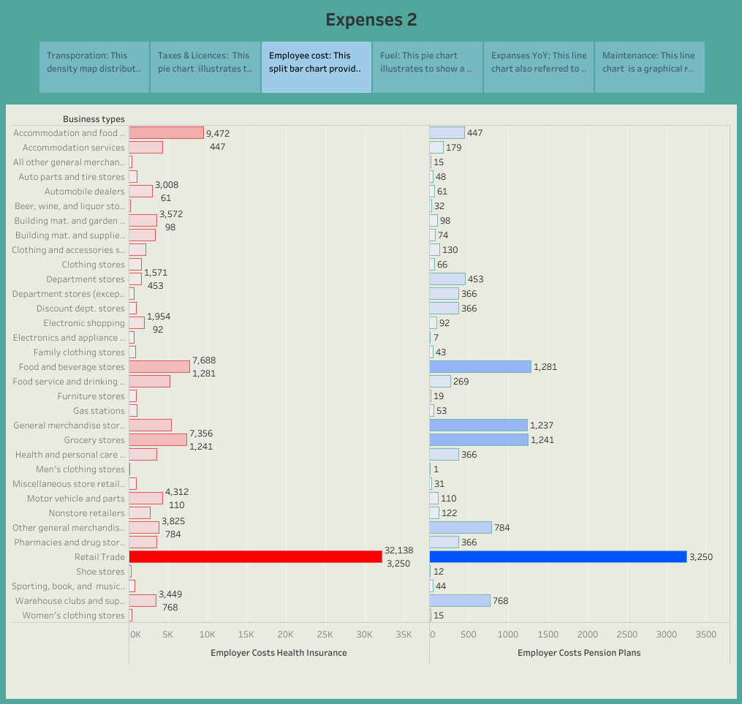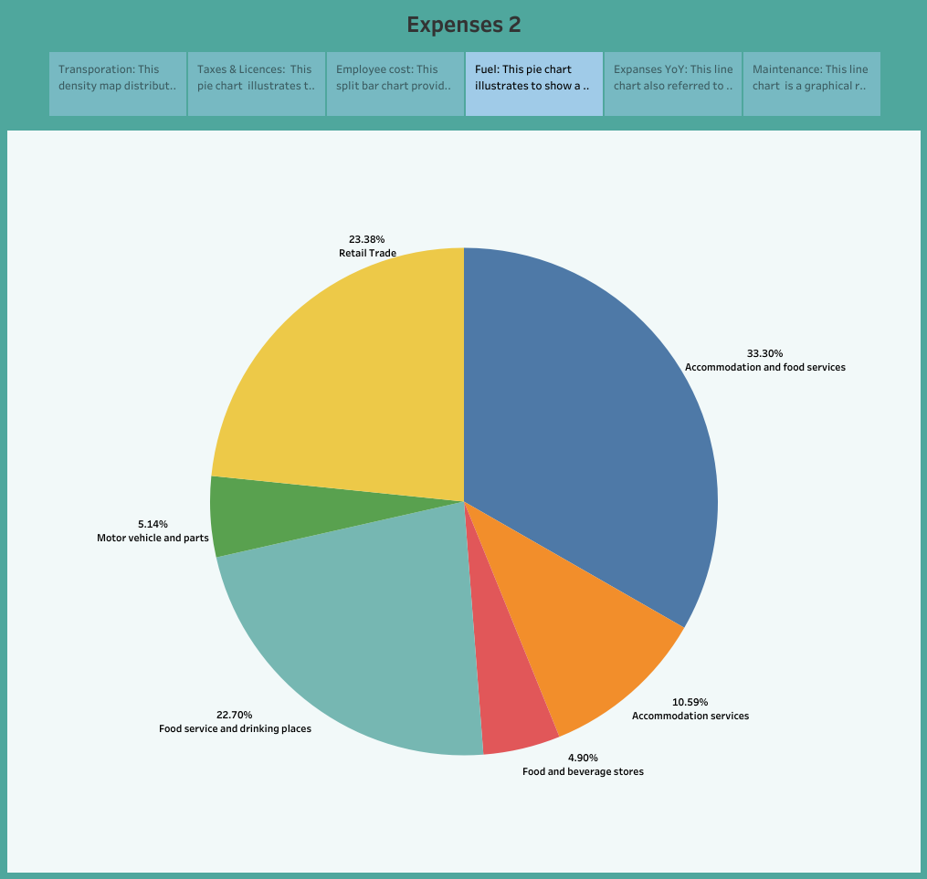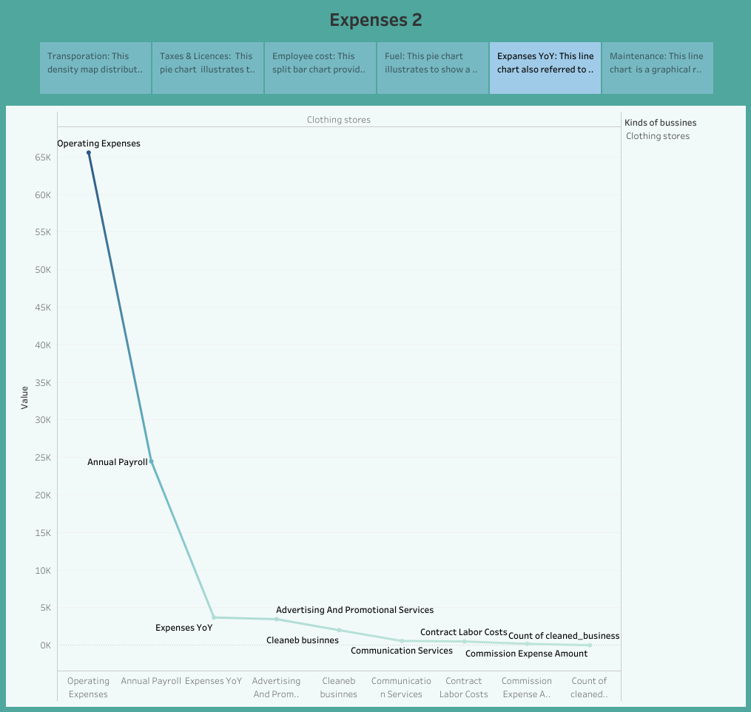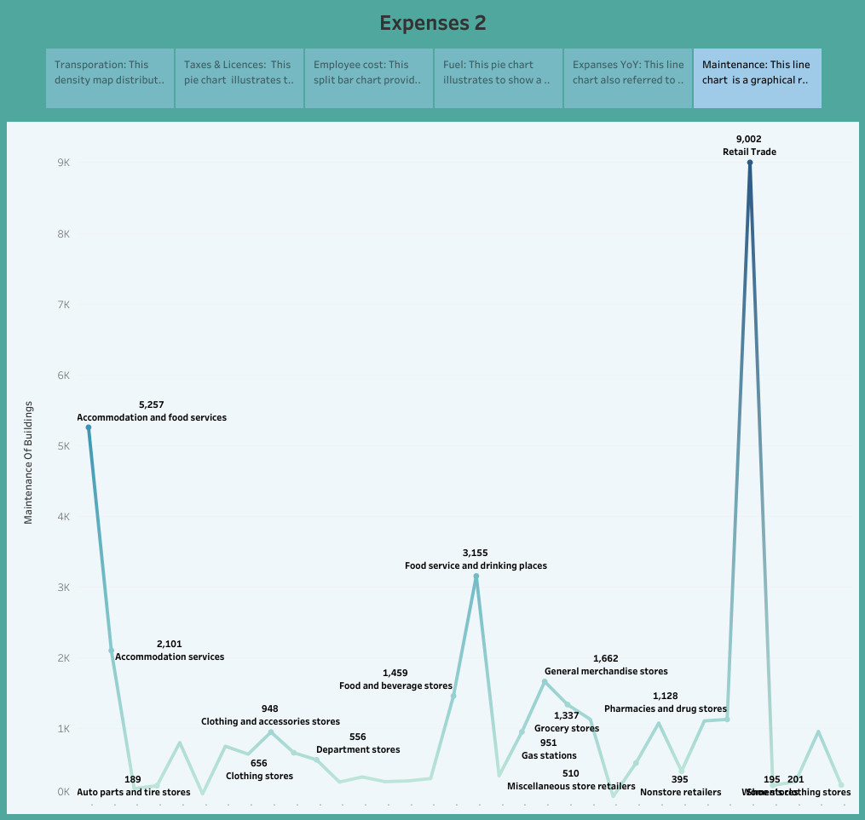

**Advantage**

* It allows you to know whether you need to raise the price of your product or you can keep it at a steady cost.
* These benefits include budget planning, resource allocation, risk management, improved decision-making, and competitive advantage. Using cost estimation, organizations can ensure the success of their projects and maintain a competitive edge in their respective industries.
* Considering the risks involved with completing the job.

Using cost estimation, organizations can ensure the success of their projects and maintain a competitive edge in their respective industries.

**DISADVANTAGE**

* Only Past Performances Can be Recorded.
* System Complexity Costly to Maintain.
* No standard procedure in estimation.
* Complexity-increasing auditing risk tends to be more expensive and its effectiveness is limited.
* The costing records only indicate previous performance, but management makes long-term decisions. Cost accounting incorporates costs at a specified pace.

**Applications**

Cost estimation helps you determine your project's budget, schedule the work necessary and manage new resources. Cost estimates are also very crucial when it comes to winning new business. Property owners also use cost estimates to assess the feasibility of their projects before embarking on actual construction. An expense is a cost that businesses incur in running their operations. Expenses include wages, salaries, maintenance, rent, and depreciation. Expenses are deducted from revenue to arrive at profits. Businesses are allowed to deduct certain expenses from taxes to help alleviate the tax burden and bulk up profits. Spending Tracker is the easiest and most user friendly Personal Finance App in the store. And best of all, it's free! The simple fact is, by tracking your spending you will be able to stick to a budget and therefore SAVE MONEY. So give it a try and have instant control over your spending. An expense tracker app allows you to monitor and categorize your expenses across different bank and investment accounts and credit cards. Some of these apps also offer budgeting tools, credit monitoring, mileage tracking, receipt keeping, and advice to grow your net worth. The best budgeting apps help you understand your income and spending so you have maximum control over your money. Budgeting apps may connect to your bank account and credit cards to automatically download transactions and categorize you spending to match the budget you choose.

Conclusion

Cost accounting is a system of recording and analyzing the cost of products or services in order to contribute towards strategic planning and improve cost efficiency. It's important for many parties involved in a business, including management, employees, and consumers. For a successful project, proper project cost management is a must! In the end, your estimated time, resources, and expenses are the ones that rule over your budget cost estimation is an important component of project management that ensures projects are finished on schedule and within budget. Since inaccurate cost estimates can have serious financial consequences for businesses, accurate cost estimating is crucial for all stakeholders engaged in a project. Cost is a topic of major importance in economics because it is an indispensable tool of the economy.

FUTURE SCOPE

Cost estimation in project management is the process of forecasting the financial and other resources needed to complete a project within a defined scope. Cost estimation accounts for each element required for the project — from materials to labor — and calculates a total amount that determines a project's budget.

Creating an estimate helps you outline the scope of a project, how much it's going to cost you (in both time and money), and how much you'll earn. In short, this document estimates the time, money, materials, and labor needed to provide a good or service. They can work on more complex projects and provide accurate estimates for their clients. Estimation engineers will also be able to use new software to help them with their work. This software will allow them to create more accurate estimates and save time on their projects.